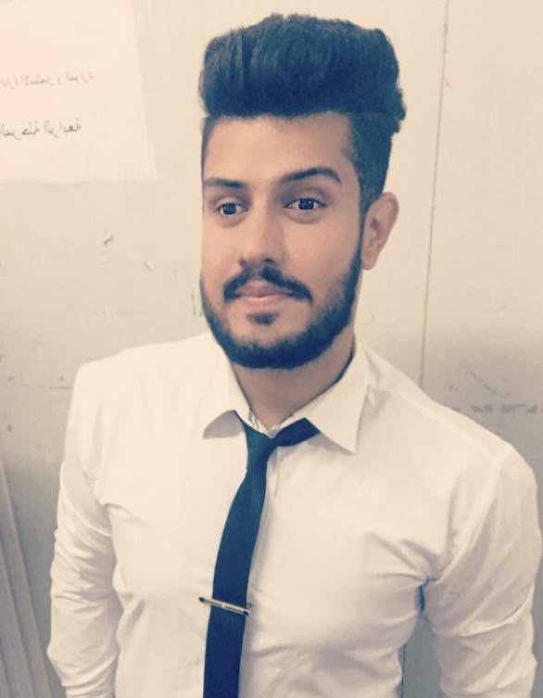

**PERSONAL INFORMATION**

**Name: Mohammed Jamal Ahmed**

**Address : karada Maryam , Baghdad, Iraq**

**Telephone : 07715802406**

**E-mail :** [**mja221097@gmail.com**](mailto:mja221097@gmail.com)

**Date of birth : 22 October 1997**

**EDUACATION AND COURSES**

**2019 graduate: Business Economics , Nahrain University ,Baghdad,Iraq**

**Specialization : Accounting and Auditing**

**22 February :** intro English courses**, level 2** **, Cambridge English institute**

**2019**

**28 February :** the basics of the internet and correspondence**, online**

**2019**

**25 December :** the basics of electronic marketing **,from Google,online**

**2018**

**24 June : Microsoft office Excel , Al-kaleej , Baghdad,Iraq**

**2018**

**26 February :** Crisis management **, Almarifa center, Baghdad,iraq**

**2018**

**14 January:** leading business ,**the American university in Cario, online**

**2018**

**3 January :** principles of investment , **from Edraak , online**

**2018**

**25 December:** Leadership skills , **From Edraak , online**

**2017**

**i**

**18 December :** Customers service, **from Edraak, online**

**2017**

**20 November:** Teamwork skills , **from Edraak , online**

**2017**

**OF EXPREIENCE**

**I worked at Cosom branch of Harthiya**

**I worked in supermarket**

**I trained in the financial control Bureau**

**I trained in the accounts department at the college of information university of Baghdad**

**Language skills**

* **Mother tongue: Arabic**
* **Other language : English**

**HOBBIES**

**Football ,Reading , body language,**